Received: .../…/… Accepted: .../…/… Published:.../…/....
Title in English (Times New Roman; size-14;)
Full name of the first author^{*1}, Full name of the second author ²
¹ Full affiliation (Country), e-mail
² Full affiliation (Country), e-mail
Abstract: (Do not exceed 150 words) (Times New Roman; Taille 12; Gras)
Enter your abstract here (an abstract is a brief, comprehensive summary of the contents of the article)
(Times New Roman; Taille 12)
Keywords: (Times New Roman; Taille 12; Gras)
(Times New Roman; Taille 12)
JEL Classification Codes: …, …, …(Adding a nandatory JEL coding mode for economic studies)

____________________

*Corresponding author

INTRODUCTION (Times New Roman; size-12; Gras)
The first subtitle opens with an introduction that presents the specific problem under study and describes the research strategy. (Times New Roman; size-12)
Title (Times New Roman; size-12; Gras)
First Subtitle (Times New Roman; size-12; Gras)
Enter here the text of first subtitle. (Times New Roman; size-12)
Second Subtitle (Times New Roman; size-12; Gras)
Enter here the text of second subtitle. (Times New Roman; size-12)
Title
First Subtitle
Enter here the text of first subtitle.
Second Subtitle
Enter here the text of second subtitle.

Table 1. Table title (this is an example of table 1)
Test 1 | Test 2 | Results 1 | Results 2 | Total Results
15.21 | 15.21 | 15.21 | 15.21 | 15.21
18.58 | 18.58 | 18.58 | 18.58 | 18.58
11.14 | 11.14 | 11.14 | 11.14 | 11.14
Source: author’s name, year, page
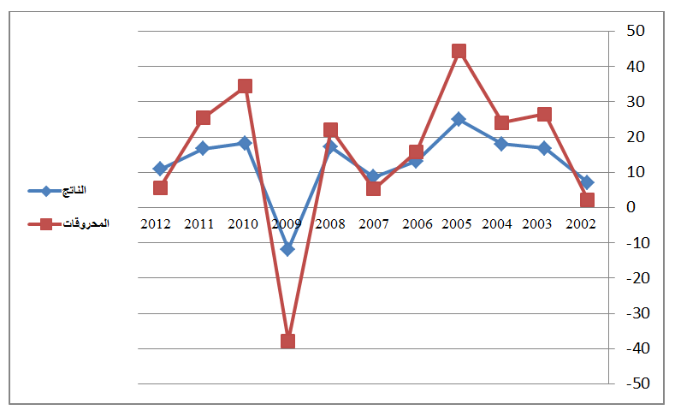
Fig.1. Figure title (this is an example of figure 1)

Source: author’s name, year, page

CONCLUSION (Times New Roman; size-12; Gras)
The conclusion of a research paper needs to summarize the content and purpose of the article. (Times New Roman; size-12)
References
References are important to the reader. Thus, quotes must be complete and correct.
Numbering all bibliographical references , and they should be in simplified font, size 12.
the Chicago manner at the end of the article, or in the APA manner.

Bibliography List :
(1) Author, "title of the article," magazine name, folder, number, and year.
Books:
(2) Author, title of the book, publisher, pages.
Forums:
(3) The author, "title of the article," name of the forum, place, year.

